Images of Footprints
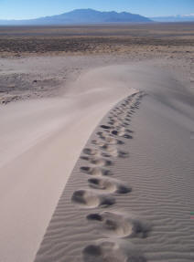 | 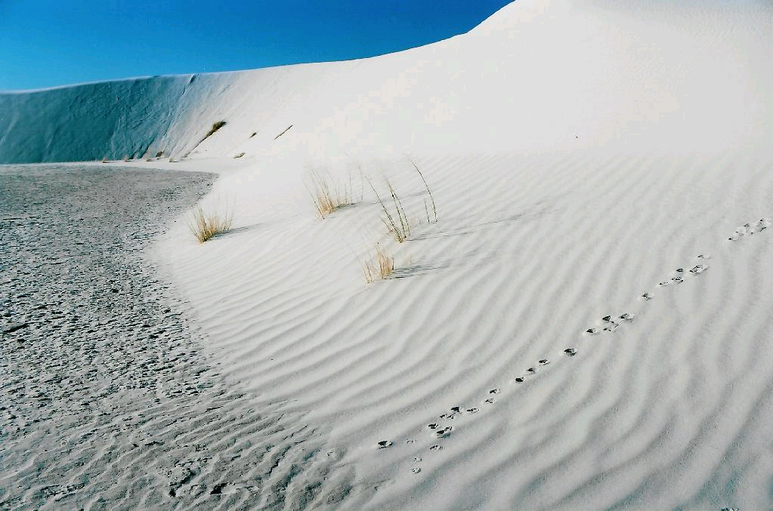
Credit Line: t Courtesy Nevada Division of State Lands  URL: http://www.lands.nv.gov/policies/policies.htm | Credit Line: © Larry Fellows; www.earthscienceworld.org/images/  Earth Science Image Photo ID: imgsr8
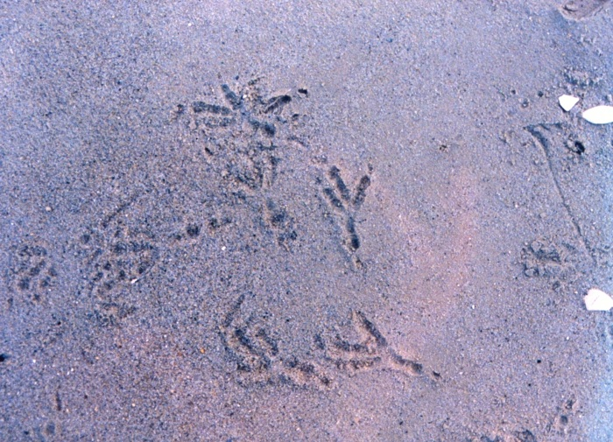 | 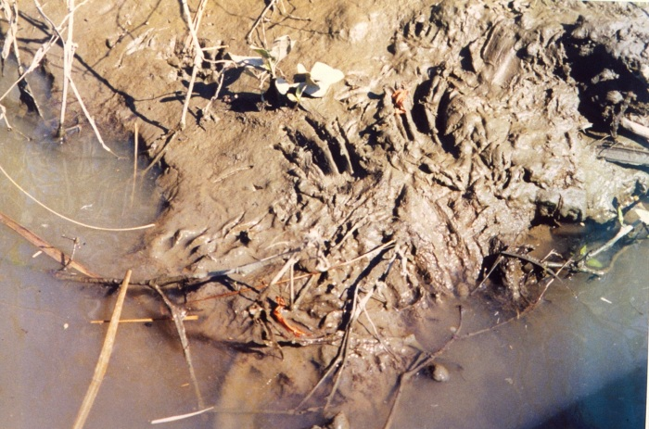
Credit Line: Courtesy NOAA  URL: http://www.photolib.noaa.gov/htmls/line2283.htm | Credit Line: Courtesy NOAA  URL: http://www.photolib.noaa.gov/htmls/line2289.htm
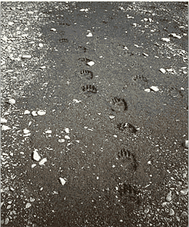 | 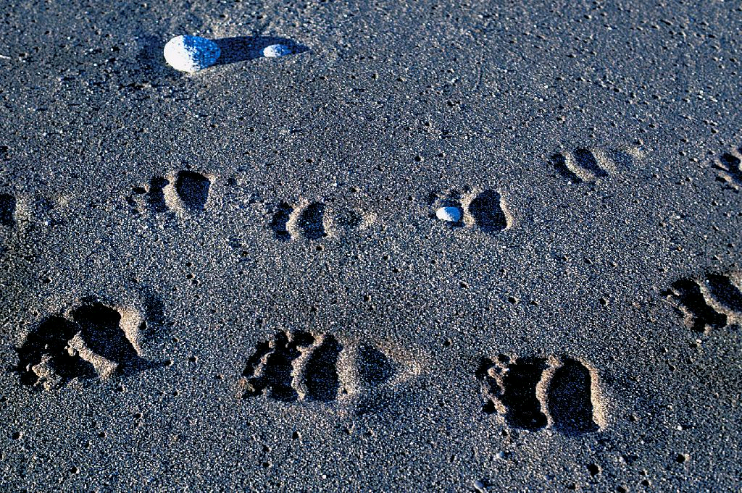
Credit Line: Courtesy NPS  Url: http://www.nps.gov/archive/kefj/planning%20and%20management/Resource%20  Management.htm | Credit Line: © Bruce Molnia, Terra Photographics; www.earthscienceworld.org/images/  Earth Science Image Photo ID: hflvh0

