Images of Weathering
**All images can be found on the Earth Science World Image Bank (www.earthscienceworld.org/images/)
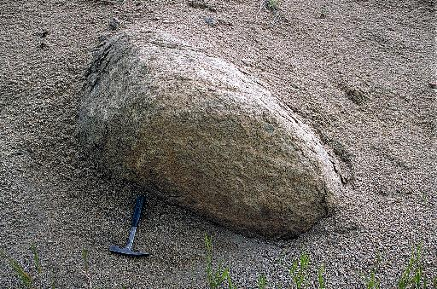 | 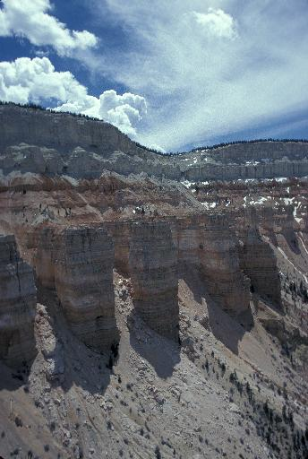
Credit Line: Copyright © Marli Miller, University of Oregon  ESW Image Bank Photo ID: hhrhuz | Credit Line: Copyright © Michael Collier  Earth Science Image Bank Photo ID: j7e0km
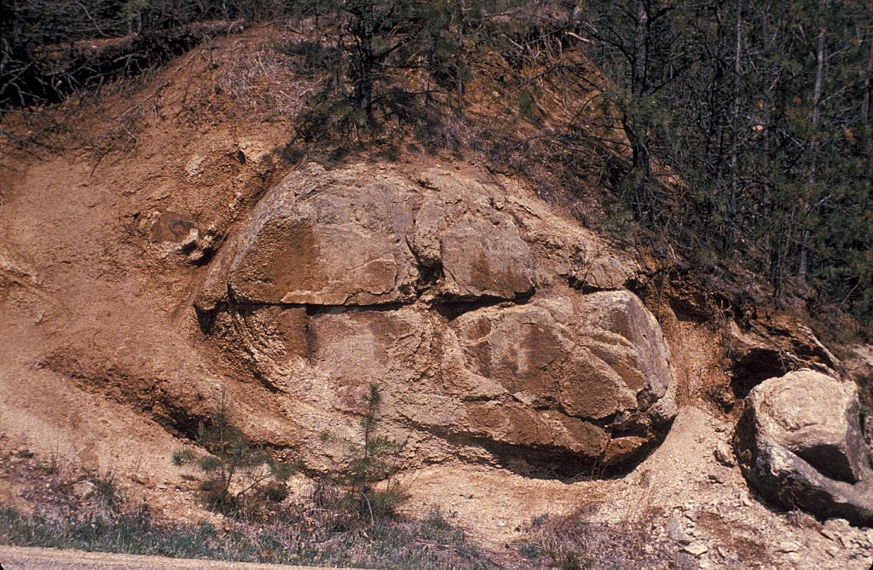 | 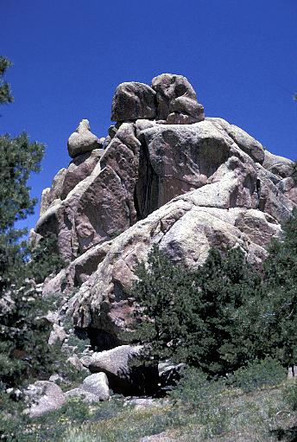
Credit Line: Copyright © Bruce Molnia, Terra Photographics  Earth Science Image Bank: Photo ID: ih0huj | Photographer: David Spier  Earth Science Image Bank Photo ID: ilfdu2

