 | Migration Nation

Desert locust

Animal (common and scientific names) | Natural history | Range: Where are they and where do they go? |  | Did you know…?
Desert locust (Schistocerca gregaria (Forskal))  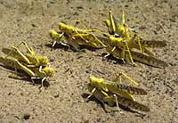 | These desert insects cause "plagues" that destroy crops. Swarms of locusts can be responsible for a huge amount of crop damage in African deserts. There can be up to 80 million locusts per square km, and these swarms have been known to cover as many as 29 million square kilometers. | Semi-arid and arid areas of Africa, the near East and SW Asia where annual precipitation is less than 200mm | Locusts spread from these arid areas outward; for instance, African locusts commonly cross the Red Sea (300 km from site of origin); from West Africa to the British Isles; and from West Africa to the Caribbean | Migrations of these long range locusts may extend up to 5000 km (3100 miles). However, it is important to note that this is a one-way migration, and that these locusts rely heavily on winds to give them the necessary boost to make their migration journey.

