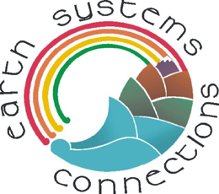 | Save the Trees, Please | Name____________

The Amazon Rain Forest

Introduction to deforestation:

One of the most famous and largest rain forests in the world is the Amazonian rain forest in South America. There are millions of species of plants, animals, and insects in the Amazonian rain forest. Unfortunately, many of these species are lost forever when tropical forests are cleared for agricultural or lumber harvest purposes. The following images will help illustrate why this happens. As you look at these images, you will be asked several questions. Think about all of these questions, answer them, and be prepared to discuss your answers with your class. The Amazon Rain Forest Questions sheet is provided to allow for you to write down your responses.

This first satellite image was taken in 1975. The colors in this image are different from what our eyes normally see. In this image, red indicates green plants, and the gray/white colors indicate roads, cities, and deforested pieces of ground (like rocks or prairies). You can see that in 1975, almost all of this region was bright red, which means it was thick green forest.

The image to the right was taken over South America. The location of the image is marked by an “X” in the image of South America above.

Next is a picture of the Amazonian rain forest taken on the ground from a location similar to that near the big “A” in the satellite image. This is sure a thick forest! What do you think you might hear if you were in a forest like this? Do you think it would be sunny or shady in a forest like this?
X

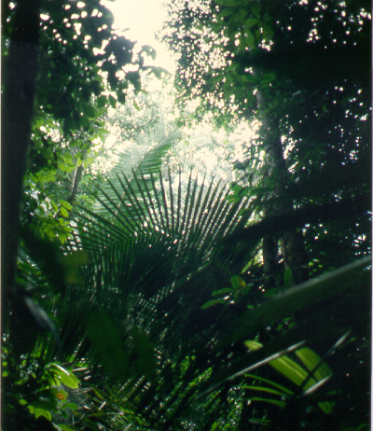 | Question 1: What kinds of plants and animals do you think you would find in a forest like this?

Now, look at the image on the first page one more time. Remember… the darker the red in this image, the darker the green would be if we were looking at it with our own eyes. In 1992, only 17 years after the first satellite image was taken, this very same region looks much different. In a moment, you will get a chance to look at some ground photos taken with a camera at about where you see the “B” in this image.

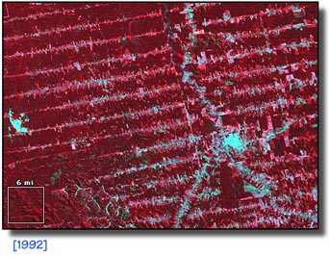

B

Question 2: What are the main differences you can see between this image and the first satellite image? What could those white lines be?

The straight lines you could see on the previous image represent roads cut through the forest. Here is an example of what one of those roads might look like.

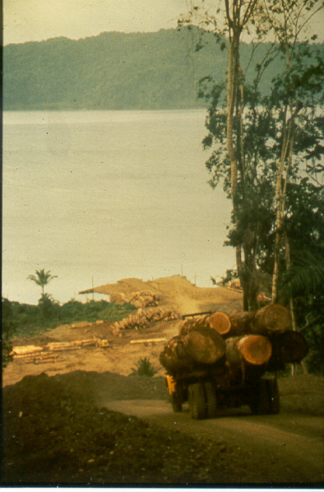

Look closely at the picture above. How many logs do you see on the back of this large truck? Can you see the end of the road?

Question 3: The road ends at a large river. What do you think might happen to the logs after the truck drops them off at the end of the road?

Now look at the next photo. It is a picture of the ground taken at the site of the “B” in the previous pink satellite image. This photo was taken during a scientific field trip to the Amazon. There is a tent and some other equipment that you can see, but what else do you notice about this photo? Where have all the trees gone?

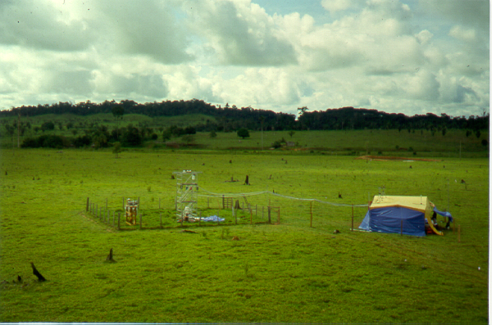

Now, let’s zoom in to part of the picture above and see what those black things are, in the middle of the field. What do you think they might be? What do you think you will see when we zoom in?

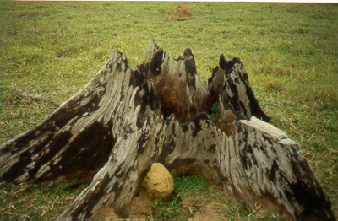

A tree stump!

Question 4: What colors do you see in the stump? How do you think it became colored in this way?

Not long ago, this grassy area was a thick rain forest. The forest was then cut down and left to dry. After the forest was dry, it was cleared by burning.

Look at the image below. Unlike those first two red images you looked at, this one is more like a photograph – the colors you see in the picture are the actual colors that you would see with your own eye. Do you see any roads? Do you see any cleared brown fields? Do you see any bright green fields? Do you see any sign of smoke? Point to or draw an arrow that points to a place where the ground might be burning. What could be happening here?

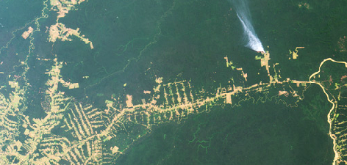

Question 5: Those stumps we saw earlier were burned! What are some reasons that a person might want to cut down a forest and clear the land by burning it?

The pictures below show how some of the wood is being used. This is a furniture shop located in a village that can be seen in the 1992 image.

Question 6: What are the pros and cons of using this wood for furniture?

Now, let’s go back to the picture of the field where the experiment tent was located. What has changed?

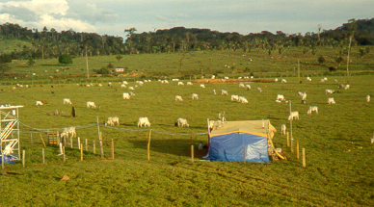

Question 7: a) What do you now see in this field that wasn’t there before?

b) Now that the forest has been cleared, how is the field being used?

- Do you think that there are more or fewer kinds of plants located on the land now compared to when the land was a forest?

d) Do you think there are more or fewer animals that use this land now, compared to when the land was a forest? Why?

In the rest of the activities that you will do in the next few days, you will see how scientists can interpret images using knowledge from the ground level. For example, below is a satellite image of a tropical rain forest area that has several different deforested areas labeled upon it. Just like the first images you saw above, this image is shown in a way that red colors mean green vegetation and blue colors mean bare soil. Pink colors mean thin vegetation areas that are re-growing.

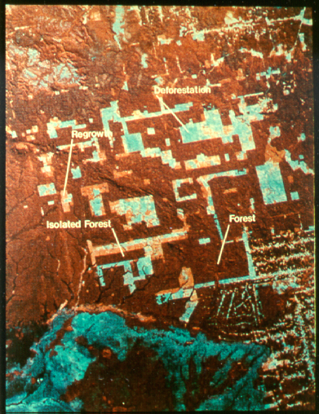
Isolated Forest
Forest
Deforestation
Regrowth

This is a large area – many miles wide. Your school playground would probably not even show up on this image! It is a good example, however, of the kind of image that scientists study all the time. As you get ready for some more explorations about deforestation, think about the following questions:

- In what ways might satellite images help to measure deforestation?
- How would animals and plants be affected by deforestation?
- How would farmers and ranchers be affected by deforestation?
- How could you be affected by deforestation?

As you will see in the next few lessons, there is much to learn about deforestation and its impact on the Earth.

