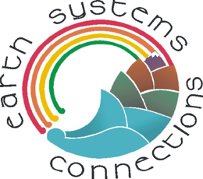 | Salmon Run

Human Impact

Directions: These pages illustrate the impact that humans have recently had on salmon populations. After reading the captions and viewing the photos, complete the Salmon Migration* and Salmon Energy* activities to learn more about that humans have had on salmon migrations.

Salmon are a nutritious source of food. Below are photos of salmon fishermen in the Pacific Ocean using gill nets. Quite a catch!

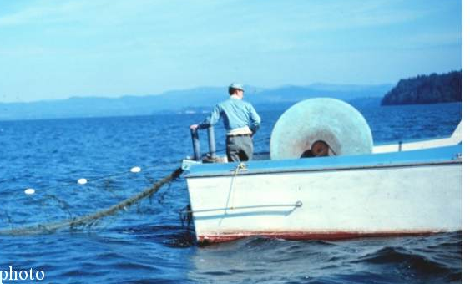 | 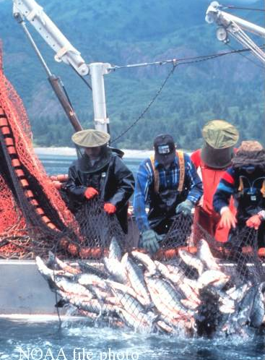
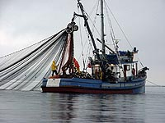

Salmon are also an important food source for Native Americans. Below is photo of people catching salmon using nets along the streams and rivers of the Pacific Northwest.

How might these fishing methods (and results) be different from the fishing vessels shown on the previous page?

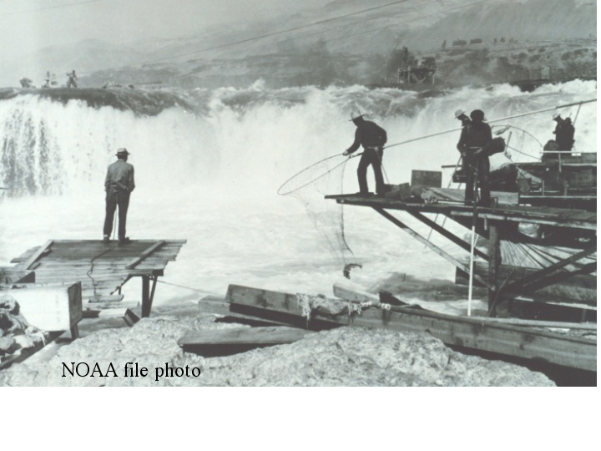

The Columbia River in the Pacific Northwest (USA) is an important route for salmon to travel to their spawning headwaters. In addition to its beauty, the river is also important for humans as a source of water, transportation, hydroelectricity, irrigation for crops, and recreation.

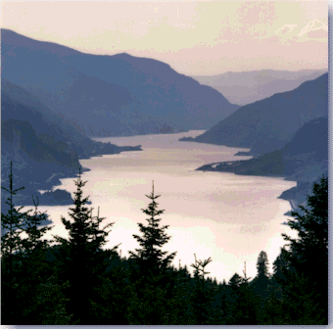
Photo courtesy of US Forest Service.

Windsurfing the Columbia! Barges on the Columbia
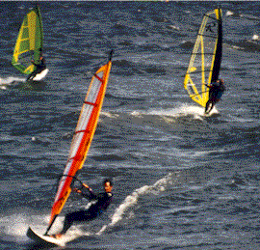 |  | 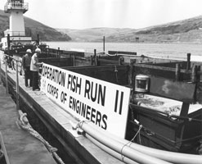
Courtesy of State of Washington Tourism Courtesy of Army Corps of Engineers.
The Columbia River Basin contains numerous dams on many of its rivers. These dams serve valuable purposes for humans like providing water for irrigation, and hydroelectric power. But for salmon they represent major barriers that significantly impact the salmon cycle of life.

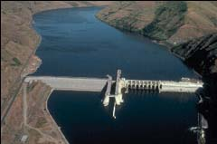
Not only do dams create barriers for fish to get around, they also slow down the flow of water, raise the temperature of the water artificially, confuse the salmon, and make it easier for bigger predators (including humans!) to catch them.
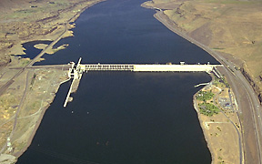
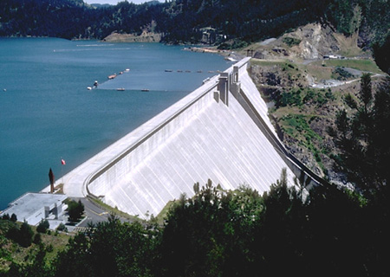
If you were a salmon, this dam would be quite a challenge! Yet it supplies energy for thousands of people in Idaho and Oregon.

What a dilemma!
Photos courtesy of the Army Corps of Engineers

Take a look at this map of the Columbia River Basin. How many dams do you see?

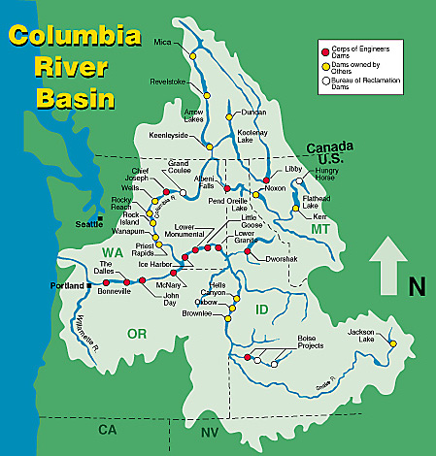

Map courtesy of Pacific Salmon Coordination Office, Army Corps of Engineers

When migrating to their birthplace spawning sites, salmon must expend energy to travel upstream, sometimes over waterfalls. Salmon must conserve energy during their migration; therefore, they do not eat when migrating from the ocean to their spawning birthplace. In addition to using energy to swim upstream and over waterfalls, salmon must use energy to spawn (lay eggs).

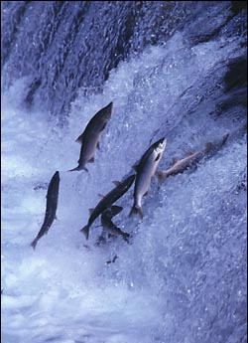
Photo courtesy of Environmental News Network

Humans have gone to great lengths to provide ways for salmon to get around dams. Yet salmon must expend extra energy as they do so by traveling through fish ladders. If they use too much energy crossing dams, then they may get lost and spawn elsewhere, or die from exhaustion before laying their eggs. Often young fish are not well suited for these artificial conditions.
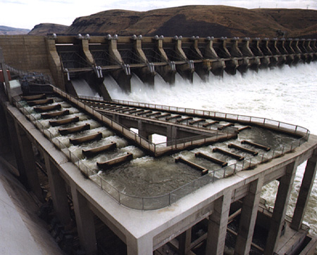
Photos courtesy of the Army Corps of Engineers

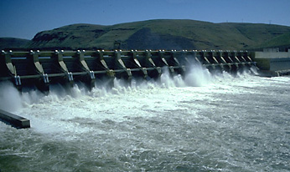
After young salmon are hatched, they grow in fresh waters for a year or two before migrating to the ocean. During this time, many young salmon may be eaten by predators or they may have difficulty getting past dams. As in this photo, the young salmon often must swim over dam spillways to reach the ocean.

Juvenile salmon are sometimes transported in barges. Environmental groups and Native American fishery agencies have criticized this practice. They believe that rather than putting fish in barges, more effort should be given to in-river migration conditions.

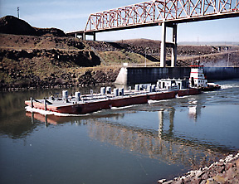
Photos courtesy of the Army Corps of Engineers

Salmon are thought to be extinct in almost 40 percent of the rivers where they originally spawned in the Pacific Northwest. Efforts are underway to remove some dams from the Columbia River Basin.

Make a list of some of the things you have learned so far about salmon.

1)

2)

3)

4)

5)

6)

7)

