 | Pie Chart Activity Sheet

The table below shows the breakdown of skiing runs at two different ski areas.

Snow Ridge Ski Area |  | Homestake Valley Ski Area
Beginner | 50% | Beginner | 85%
Intermediate | 25% | Intermediate | 5%
Advanced | 15% | Advanced | 6%
Expert Only | 10% | Expert Only | 4%

- Which area has the greatest proportion of beginner runs? ___________________

- Which area has the greatest proportion of advanced runs? ___________________

Sometimes it is helpful to use a chart to display data like this. Here, for example, is a pie chart that illustrates the percentage of ski runs at Homestake Valley.

3. Make a pie chart to display the percentage of runs at Snow Ridge Ski Area. Some dashed lines have been placed in the chart to help you be as accurate as possible. Be sure to complete a key.

Snow Ridge Ski Area
key

When the data get complicated, making a pie chart can become more difficult than the previous example. Explore one method for creating pie charts on the following page.

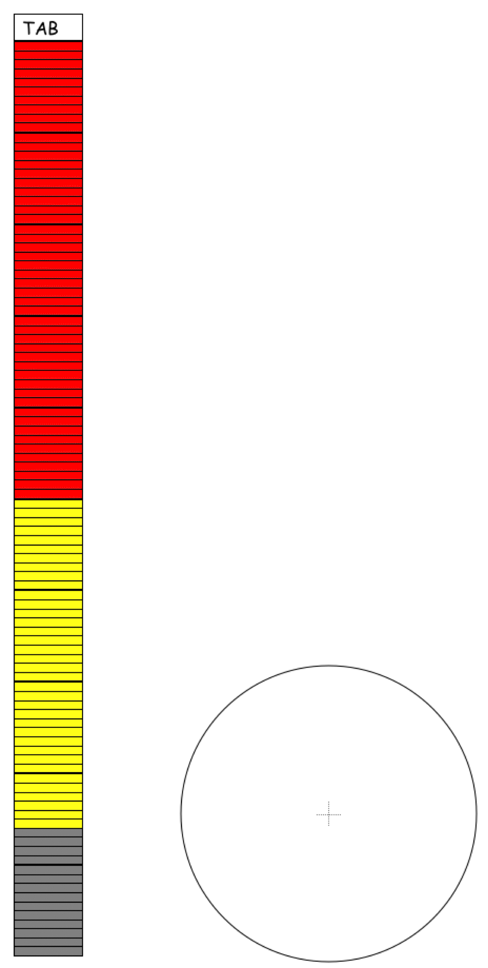
One Way to Make a Pie Chart

Sometimes making a pie chart is more difficult than one you completed on the previous page. Here are some steps to turn any data in percentage form into a pie chart. For this example, assume you have 50% in one category, 36% in a second category, and 14% in a third category.

Step 1: This bar has been colored based on the percentage data (50%, 34%, 16%) noted above. Every bar = 1%, and each new color represents a new category. So, 50 bars were colored red, 34 bars colored yellow, and 16 bars colored grey.

Step 2: Use scissors to cut out the bar grid into a long strip.

Step 3: After cutting your bar chart into a strip, form it into a circle. Pull the ends of your bar together to make a cylinder. Tape the ends so that the last bar of the table lines up with the first bar of the table (next to the tab). Tape them so that the colored bars are on the outside of the cylinder. Your cylinder should match the circumference of (distance around) the circle below. Place your cylinder on the outline of the circle.

Step 4: Once you place your cylinder on the circle, do not move it again! Now, make marks along the outline of the circle that correspond to each differently colored section of shaded bars. (These are your categories.) When these marks have been made, draw a line from each mark to the center of the circle to make your individual “pie” pieces. A pie chart!

More on Pie Graphs

Sometimes your data do not come in the form of percents like the preceding example. That is fine! What you need to do is mark off your strip in equal parts, one for every individual data point you have. (You might, for example, make each part one centimeter.)

For example, suppose you took a survey of your friends at school about their favorite lunch menu items. 13 said pizza was the best, 10 said that soup and salad was best, and 8 said that the sub sandwiches were the best. Even though those numbers are not in percent form like the previous example, you can still do the same thing with a fraction bar. Check it out.

Cut here!
1. Split your bar into 31 equal parts. Color in the parts according to your data (13 red = pizza; 10 blue = soup; 8 yellow = sub sandwiches.

2. Then cut the strip after your last bar.

3. Wrap your new bar into a circle, and tape the ends together so that the first red bar touches the side of the last yellow bar.

4. Your circle becomes your new pie chart! Mark the starting point of each new color on the edge of the circle, and complete the chart as you did in the first example.

On the last page of this worksheet are several templates that you can use to make your own pie charts.
Subs
Pizza
Soup

- Use the “Pie Chart Template” on the last page of this worksheet to make pie charts for the following problems.

Problem 1: The student council took a poll of 100 students and asked them to identify their favorite school subjects. Here is the data they collected. Display the data in a pie chart.

Math: 21 | Science: 34 | PE: 26 | Art: 19

Problem 2: In a taste test, a grocery store asked customers to sample three kinds of peanut butter, and then rank their favorite sample. Display the data below in a pie chart.

Peanut Buster | Walter’s Old Style | Big Chunk
23 | 39 | 14

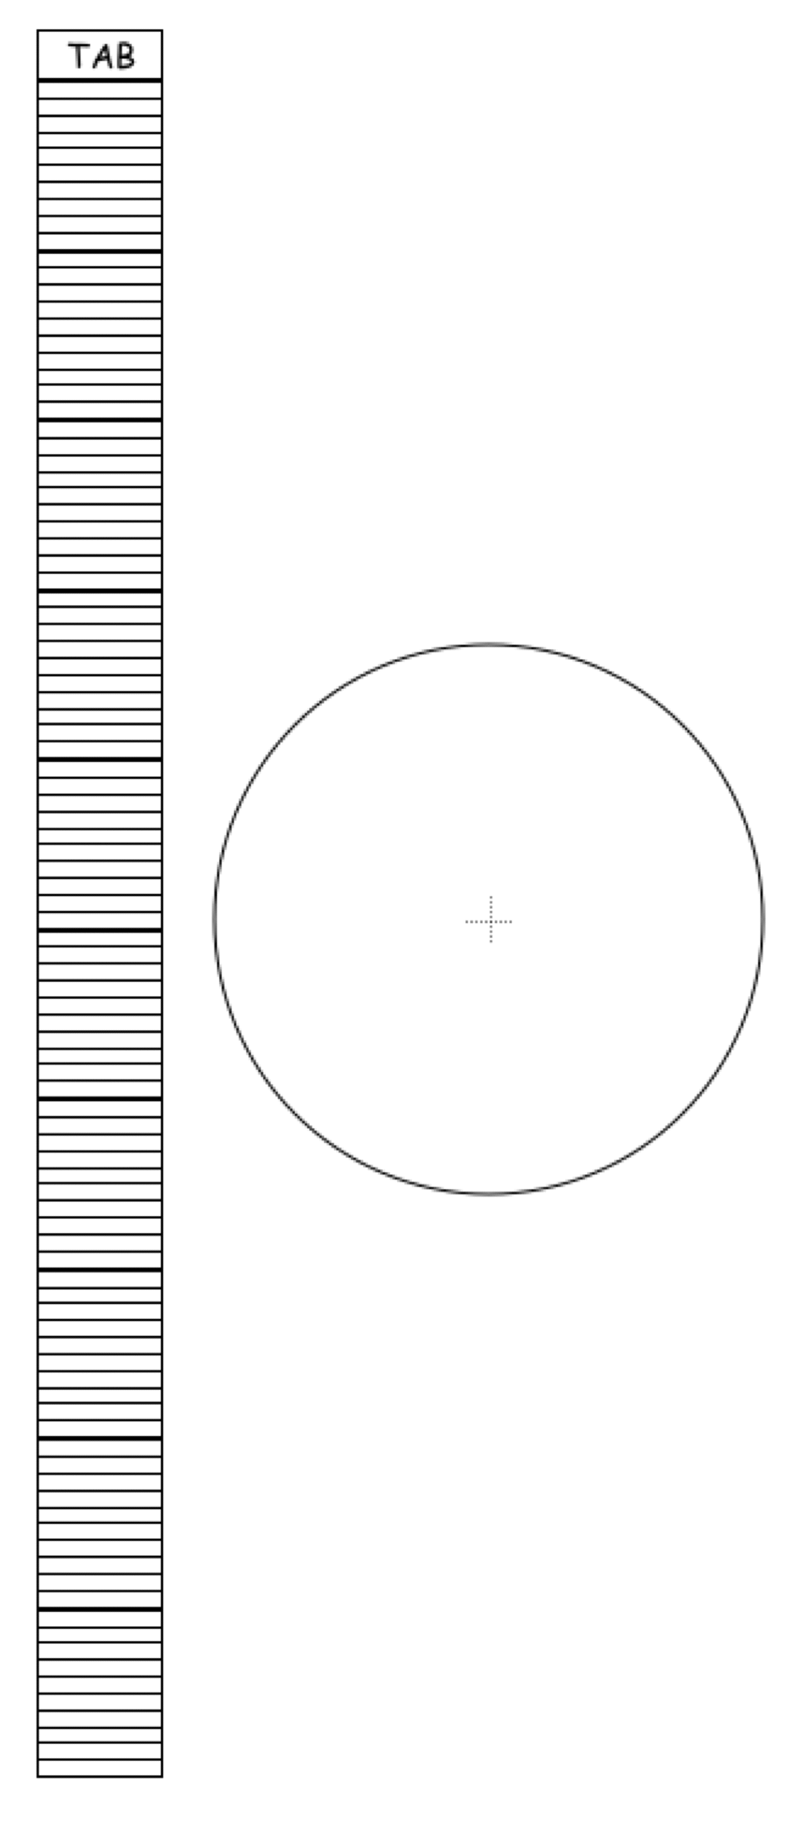
Use this bar chart,

and this circle,

for instances in which you have percentage data. There are 100 individual cells in the bar. The bar will wrap around the circle.
TAB
If you do not have data in percentages, then you may use this bar. Be sure to divide it into equal cells, one cell for every data point. Cut the bar after your last cell, wrap it into a circle, tape the tab to the last cell, and then trace the circle to make your pie chart.
Pie Chart Templates

