Images of Fossils
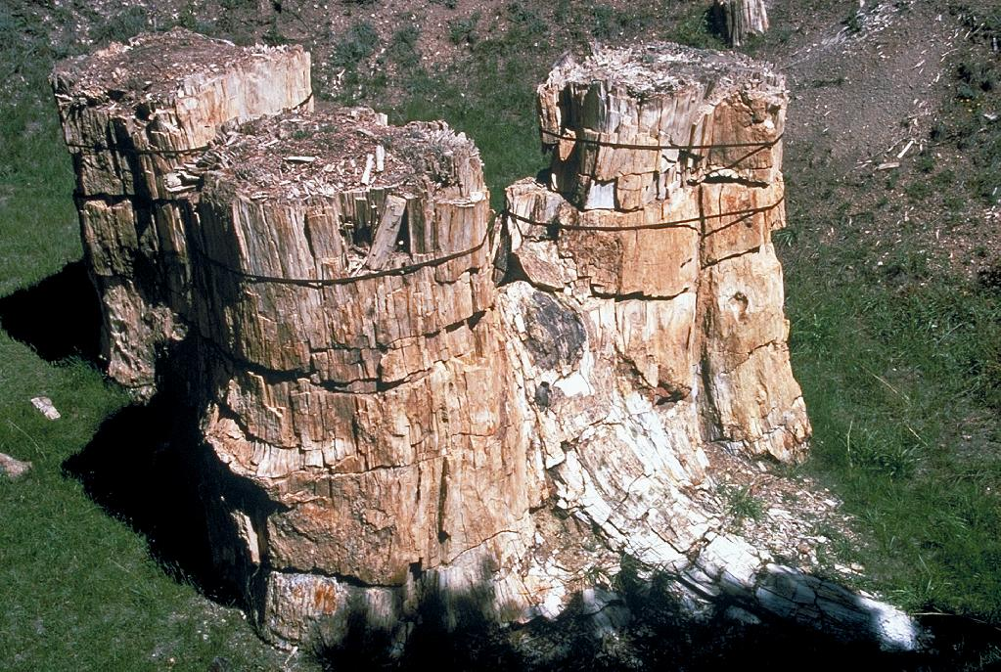 | 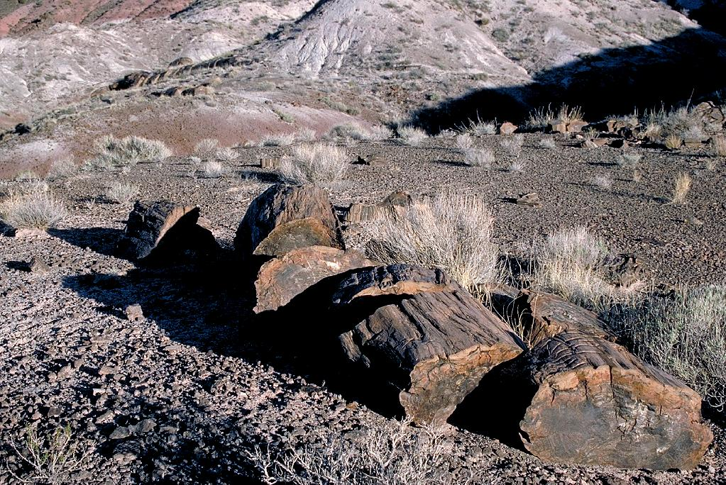
Credit Line: t © Marli Miller, University of Oregon  ESW Image Bank Photo ID: hc26gq | Credit Line: © Marli Miller, University of Oregon  ESW Image Bank Photo ID: hc26co
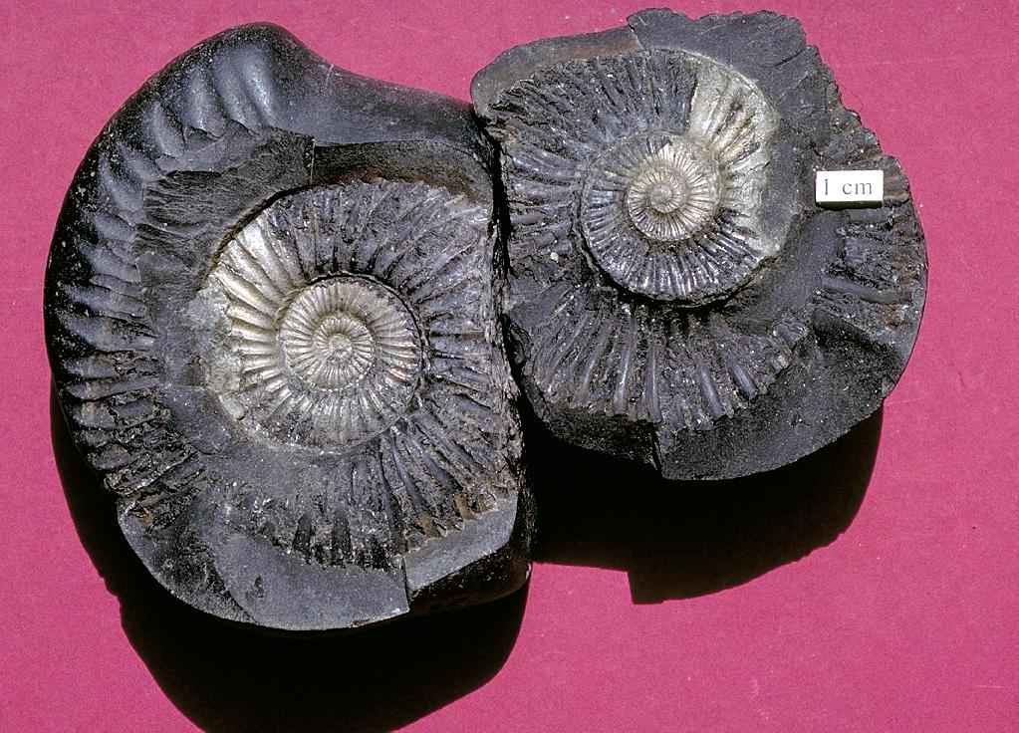 | 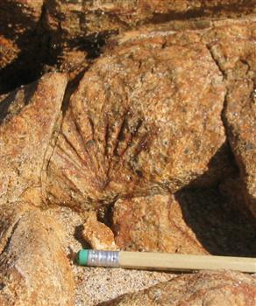
Credit Line: © Marli Miller, University of Oregon  ESW Image Bank Photo ID: hc25vs | http://geomaps.wr.usgs.gov/sfgeo/geologic/images/fossil-sandst.jpg
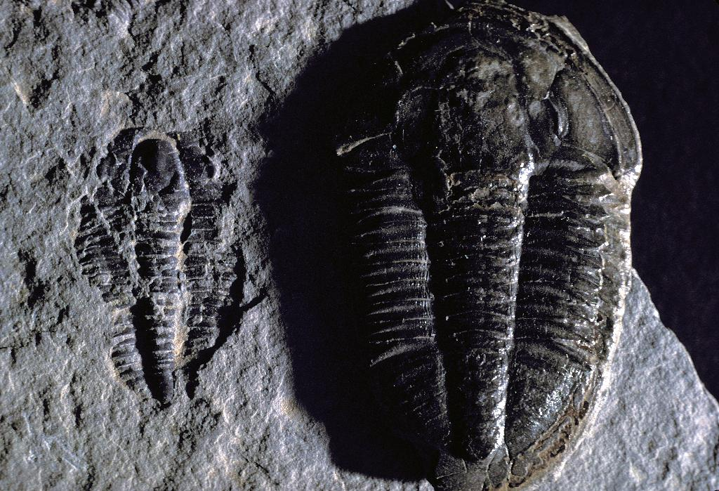 | 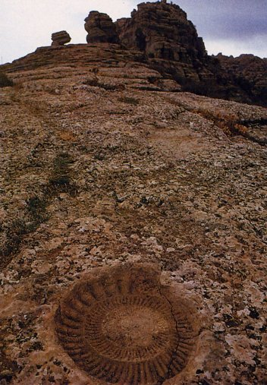
Credit Line: © Michael Collier  ESW Image Bank Photo ID: iup1zz | http://education.usgs.gov/schoolyard/IMAGES/THUMBS/FossilOutcrop.jpg
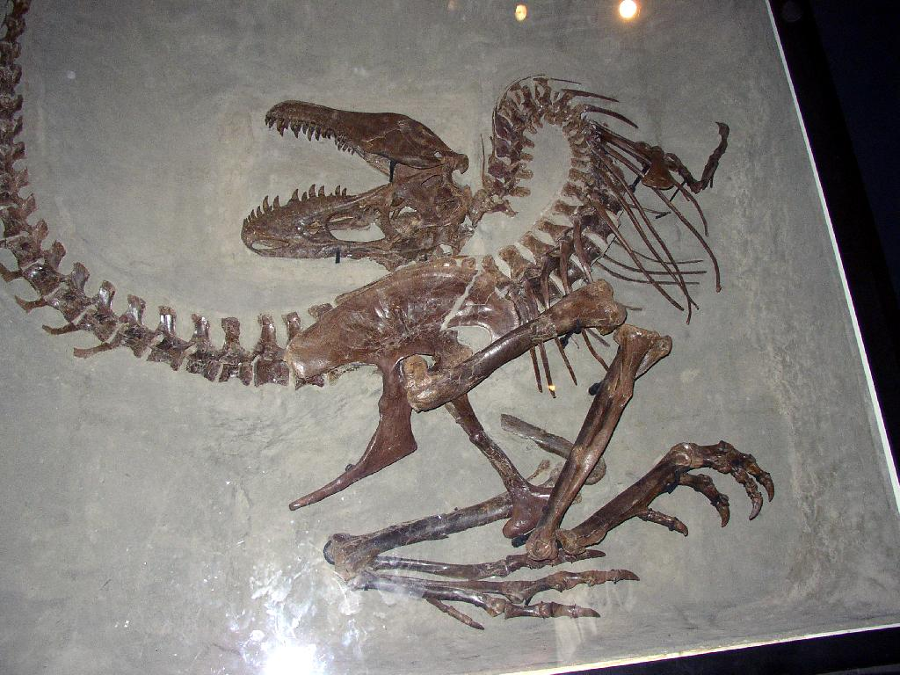
Credit Line: © Abi Howe, American Geological Institute
ESW Image Bank Photo ID: hpdzvh

