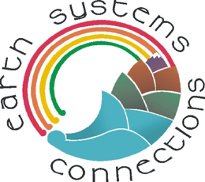 | Ecosystems Connect:  Ecosystems from Space | Name: ________________

In this activity, you will view images of ecosystems of the Earth taken from satellites orbiting the earth. Questions are provided for each image to help you examine these colorful pictures captured by satellites flying hundreds of kilometers above the earth’s surface. Use a separate sheet of paper for writing your answers to the questions in this activity.

The following ecosystems are featured in this activity sheet.

      - Deciduous forest, salt ponds, and marshland

      - Tropical rainforest

      - Desert and the Nile River

      - Prairie and croplands

Deciduous Forest, Salt Ponds, and Marshlands

Below is a Landsat satellite image of Fremont, California.

1) Can you see the deciduous forest on the upper right of the photo? What do you think the dark green lines are in this forest?

2) What might the large white portion of the image represent?

3) Can you see the muddy brown and green water on the lower left? That is a part of San Francisco Bay. What do you think the green and brown shapes next to the water might be?

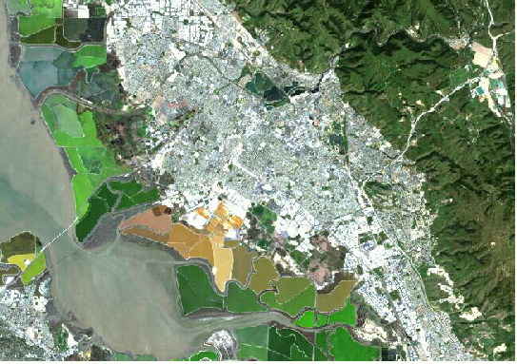

Answers:

1) The dark green lines are shadows that are caused by hills and valleys.
2) The white part is the city of Fremont, California. The white is concrete roads and buildings. Some green parks can be seen within the city—can you see them?
3) The green and brown shapes between the water and city are salt-producing areas called salt ponds. Salt water from the bay has been used to produce salt in these ponds for the past 150 years. In 2002, these salt ponds were sold by the salt company, and are being restored to tidal marsh ecosystems that will allow many birds and other wildlife to come back to the bay to live.
Here is a close-up photo of some of the salt ponds:
Here is an even closer photo of a woman getting a water sample from a salt pond:

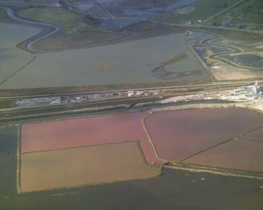
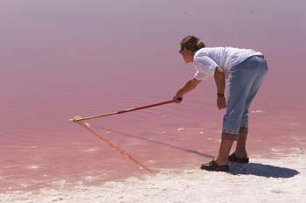
This is a beach of salt crystals!

See the ridges around the salt ponds in the left photo? These ridges were made by people to separate the salt pond water from the surrounding bay water. As time goes by, the sun separates the water from the salt because water evaporates into the air, but the salt stays behind in the pond. So the pond gets more and more salty until the salt crystals actually form on the pond bottom. This salt can be gathered and sold. People have made these ponds so salty, only a few types of animals can live in the ponds! Some of these organisms, such as red brine shrimp, give the ponds their different colors. Some birds eat these brine shrimp. When the salt ponds are restored back to their original marsh ecosystem, some of them will have much more plant life and look like this:

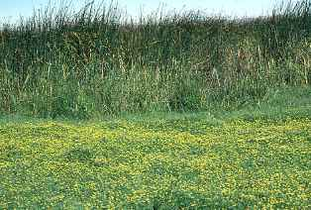

On a separate piece of paper, write about how you think the salt pond ecosystem will be different from the marsh ecosystem. Think about biotic and abiotic parts of the ecosystems as you write your answer.

Tropical Rainforest

This is a satellite image of Rondonia, Brazil in the year 1975. In this image, healthy trees and other plants appear red in color, and deforested land and urban areas (cities or roads) appear light blue or white. A river is also shown on the right side of the image. Can you see it?

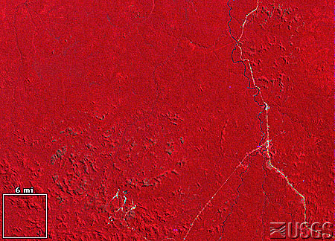

The next two pictures show the same area in 1986 and 1992. (1) What do you notice about different amounts of red and white/blue in the images? (2) What do you think is happening in this region of Rondonia, Brazil?

1986 1992
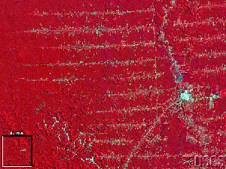 | 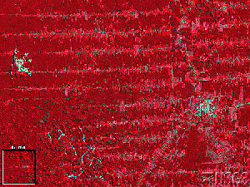

Answers:
- The white/light blue areas appear to be increasing in noticeable patterns. The forests of this area are rapidly being cut down. The white lines are roads that are used for logging operations.
- This type of logging pattern is called “herringbone” logging. Loggers cut roads deep into the forest, and then cut trees down on either side of the road for easier removal.
Desert and the Nile River

Below is a satellite image of the northeast portion of Africa, where the mighty Nile River flows. History tells many great stories about civilizations of people who lived near the Nile River. (1) Study the image – can you find the Nile River? What color is the land near the river? Which direction is it flowing, and how do you know? (Hint: find the oceans.) (2) Can you find the desert? What color is it? Do you see streaks on the left side of the image? What do you think caused those streaks? (3) Where do you think most people in this region of the world live? If you wanted to grow crops in this area, where would you want to live? Why?
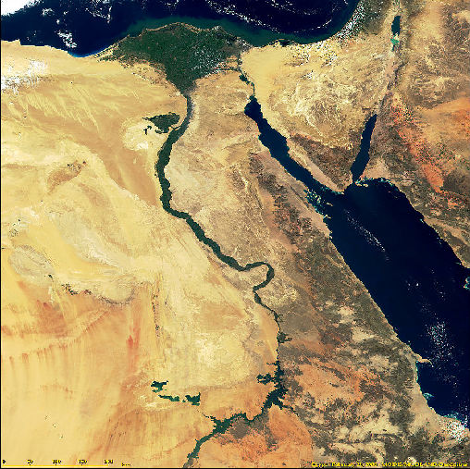

Answers:
What are these streaks?
- The land along the Nile River is green because of the vegetation that grows along the river. It flows north (from the bottom of the image to the top) into the blue Mediterranean Sea.
- The brown colors represent the desert ecosystem. The streaks in the desert are sand dunes caused by wind.
- Many people live along the banks of the Nile because it provides water to nourish plants and animals.

Prairie and Croplands

This image was taken by the Landsat 7 satellite on April 18, 2000. The image is of South Dakota. In this image, red and pink represents green vegetation on the ground. (1) What colors do you see in the image, and what do you think these colors might represent? (2) Do you see red colors that represent green vegetation on the ground? South Dakota is very cold in the winter, and begins to warm up in April. Would you expect to see a lot of red? What colors would you expect if we looked at the same region two months later, in June? How does this land surface compare with the tropical rainforest of Brazil? (3) Can you find the rivers? What color are they? Why do you think some blue areas are thicker than others?

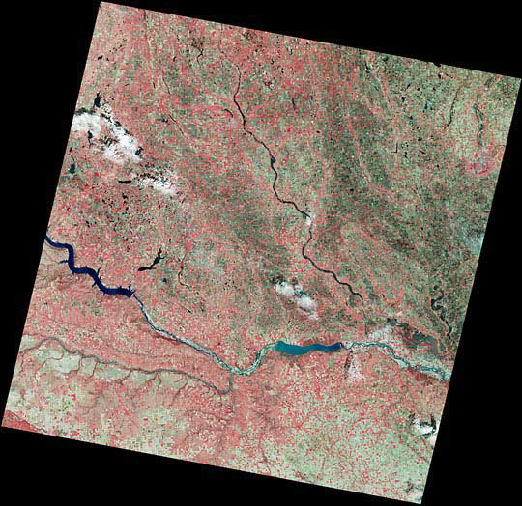
What happened to the river right here?

And here?

Answers:
- White represents clouds near the center and in the left portion of the image. Blue represents water (lakes and rivers). Brown represents soil without green plants on it. Pink represents prairie and cropland that has a little bit of green vegetation on it.
- The specks of red all over the image represent new, green growth after the winter. In June, this image would contain much more red representing the green grasslands, crops (such as wheat, soybeans, and corn), and other growing plants in the upper midwestern U.S.
- There are several noticeable waterways in the image. Most are generally flowing from west to east (left to right). The blue rivers are thicker in some areas because of dams. Two dams are clearly apparent in this image. These dams are on the Missouri River, and are used to irrigate fields, supply water for cities, and produce electricity.

