 | Hold on Tight! | Name __________

Root Connections

- Look at these photos below. They are pictures of a tree that has been blown over by very strong winds. What do you notice about the tree’s roots? Can you see any soil or rocks held by the roots?

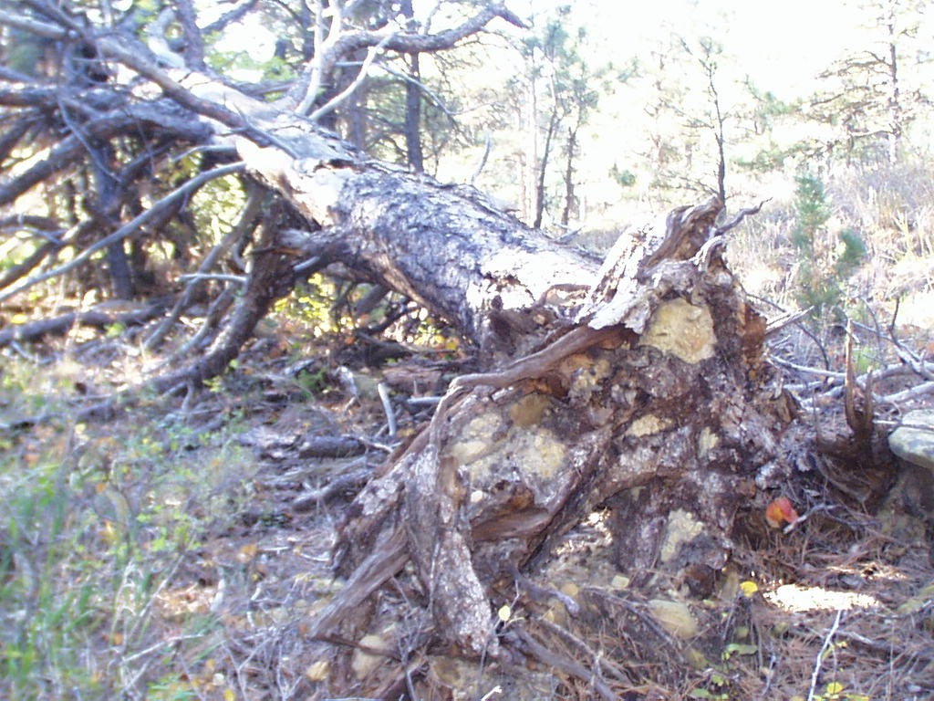
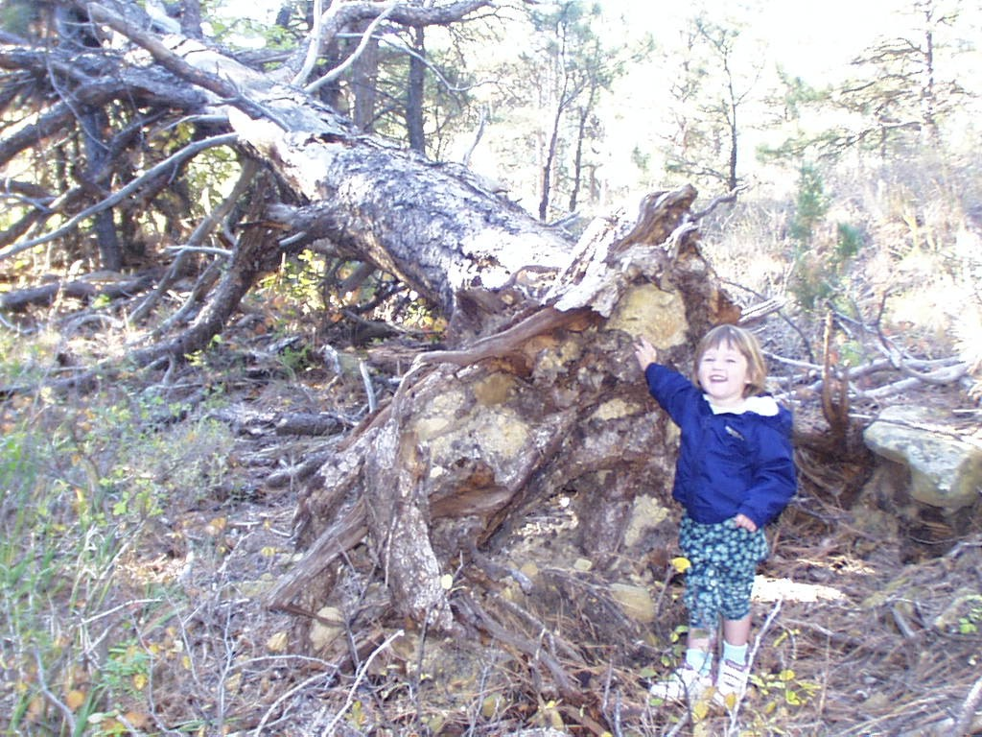

- The picture below is of a desert area, with lots of sand dunes. Do you see any plants in the photo?_____ Do you see any sand being blown by wind? ____ Why do you think sand dunes are blown by wind so easily?

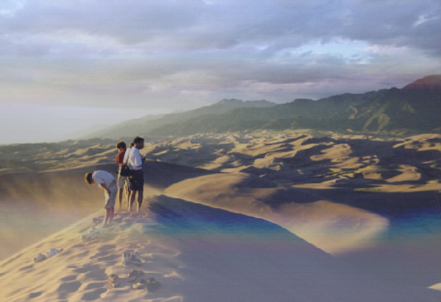

- Wind and water carry loose soil away. This process is called erosion. Roots keep soil in place and plants need soil to grow. If the soil eroded, would you expect to find plants growing there? ____ Explain your answer:

- Below is a satellite image map of the Red Sea on the northeastern part of Africa. Two close-up satellite images of this area are also included. In the close-up images, do you see much green around the Red Sea? Do you think you might find many plants in this area? Do you think the soil will be loose or tightly held to the ground near the Red Sea?

One of the images above was taken by a satellite during a calm day, and one was taken during a very windy day. Which day do you think was which? How can you tell?

- Once upon a time in the United States (in the 1930’s) it was very dry for many years in a row. A long, dry period such as this is called a drought. During droughts, do you think there would be more or fewer plants on farms and ranches? ________ Why?

- Do you think that there might be more or less soil erosion by wind during droughts? __________ Why?

- Now, look at the photos below, taken on the Great Plains of the United States in the 1930s. This and other dust storms throughout the Great Plains is what people now call the great “Dust Bowl”. Since the “Dust Bowl”, farmers have worked hard to keep topsoil from blowing away. How do you think farmers could avoid another “Dust Bowl”?

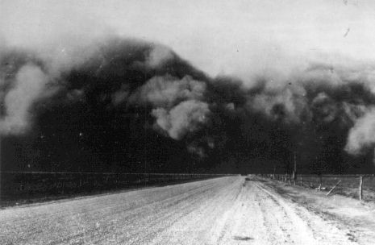
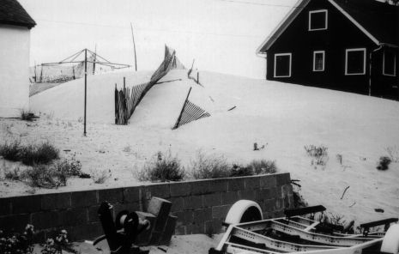
After the dust storm!

Here comes a dust storm!

8. We have seen that plant roots and soils are closely connected. Why are plants important for soils, and why are soils important for plants?

